Hosting Proforma
Northern Ireland Fire and Rescue Service

Name of Host
Organisation

1. Interchange Manager’s details
Shirley McDonnell
Name

Organisation/
Northern Ireland Fire and Rescue Service
Department
NIFRS Headquarters
1 Seymour Street
Lisburn
BT27 4SX
Address

Telephone Fax number
028 92 664221

Number
Shirley.McDonnell@nifrs.org

E-mail

Secondment – 18 months with possible extension

Type of Opportunity

2. Details of hosting opportunity

Description of opportunity

Payroll Manager

The Northern Ireland Fire & Rescue Service (NIFRS) protects and serves the entire population of Northern Ireland, an area of over 5,500 square miles and with a population of 1.9 million, providing them with a range of fire and rescue services.

NIFRS has four staff cohorts, each of which has its own structure with regard to Terms and Conditions of Employment.

The payroll manager is responsible for the effective and efficient management of the payroll team and systems, ensuring the timely processing of payrolls in compliance with internal policies, legislation, best practice and national/local terms and conditions of employment.

The payroll manager will take a key role in systems and service improvement including IT systems functionality and development. The payroll manager will also play a significant part in the upcoming project to migrate from legacy to new computerised systems.

Main objectives of the opportunity

The post holder will lead a payroll team of four staff and will ensure the timely processing of payroll in compliance with a range of policies and underpinned by a suit of internal controls.

This will include a review and checking process to ensure completeness and accuracy of payroll data, ensuring sufficient funding and also the development of robust internal controls as below:

- The performance of reasonableness tests on payroll system outputs by using scanning analytics and comparison tests with manually performed complex calculations.

- The performance of a monthly payroll reconciliation by analysing data, checking and reconciling payroll information and making calculations.

- Development and implementation of policies, procedures and guidance to provide assurance on high standards of corporate governance.

- Monitoring of payroll bank accounts to ensure sufficient funds are available to meet business needs.

The post holder will also be responsible for handling sensitive personal data and ensuring that the requirements of the General Data Protection Regulation (GDPR) are met.

The post holder will also play a key role in the NIFRS Service Improvement Programme by leading on the migration of existing payroll services to new software systems and processes.

Full Job Description and Person Specification attached in Appendix 1

3. Skills requirements

What qualities, skills and experience is required from the individual

Either:
1A Possess a degree or equivalent level qualification in a business-related subject, ie, Payroll or accountancy - CIPP, CCAB or AAT; AND
Have at least two years’ experience working at a supervisory level in a payroll function within a complex large organisation, multi-site and multi-disciplinary *, to include:

- providing specialist advice on payroll issues including implementation of legislative and statutory payments;
- using integrated payroll software systems.

OR

1B Possess a minimum of five years’ experience working in a payroll function within a complex large organisation, multi-site and multi-disciplinary *, to include:
- at least two years’ at supervisory level;
- providing specialist advice on payroll issues including implementation of legislative and statutory payments;
- using integrated payroll software systems.

- Have at least two years’ experience of managing a team to deliver results within a target driven environment, planning workloads, defining objectives, achieving deadlines and implementing action plans.
- Competent in the use of Windows and other Microsoft applications.
- Demonstrate:
- excellent planning and organisational skills;
- deliver high quality work with excellent attention to detail;
- excellent communication skills (both oral and written) and the ability to advise and influence senior management;
- a strong customer orientation.
5 Possess a full, current UK driving licence or have access to a form of transport which enables them to fulfil the full requirements of the job.

4. Personnel: Please state below

Who will the individual report to?
Financial Services Accountant

Who will be the individual’s line manager and/or reporting officer?
Financial Services Accountant

5. Transfer of learning
Please give details of how the Opportunity will benefit your organisation, the
individual and their organisation.

This is a fantastic opportunity for an experienced payroll manager to gain experience in another organisation during a period of significant change and improvement and to play a key role in the migration of a payroll system to a new computerised platform.

6. Logistics
Please provide details of the likely start date, duration, location, form of transport required, resources (i.e.; desk, PC, etc.) and funding arrangements for the opportunity.

Start Date: As soon as a suitable candidate has been identified and a release date has been agreed.

Duration: Secondment – 18 months with possible extension

Location: NIFRS Headquarters, 1 Seymour Street, LISBURN, BT27 4SX

Resources: This post is office based and all resources will be provided. There may be the opportunity for Hybrid Working however the post-holder will be expected to be flexible to meet the needs of the role.

Funding: NIFRS will meet the salary and associated costs for the role. The salary range is currently £37,035 to £39,513.

Further information: Process will consist of shortlisting during February 2025 and may be followed by interview if required, which will take place in February / March2025. For further information please contact Shirley McDonnell on Tel: 028 9266 4221 or by email at: Shirley.McDonnell@nifrs.org

Closing Date: Applications must be submitted by Noon on Monday 10 February 2025 to:

For NI Civil Service departmental staff only: secondments@hrconnect.nigov.net

For employees from all other member organisations: interchangesecretariat@finance-ni.gov.uk

7. Endorsement

Interchange Manager

Signed:
Shirley McDonnell

Date:
24 January 2025

Annex 1
Job Description
Reference Number: I/C 09/25 Date: January 2025
Directorate: Finance & Support Services
Department: Finance
Job Title: Payroll Manager
Grade: PO1
Reports to: Financial Services Accountant
MAIN PURPOSE
The Payroll Services Team Manager is responsible for the effective and efficient management of the Payroll Services Team and systems, ensuring the timely processing of payrolls in compliance with internal policies, legislation, best practice and national/local terms and conditions of employment.
The Payroll Services Team manager is responsible for the monthly salary payment of approximately 800 whole-time firefighters, 59 Regional Command Centre personnel and 249 support staff.
To contribute as an integral member of the Finance team to the provision of a modern, professional and responsive Financial Services Team to support the vision and mission of NIFRS outlined below:

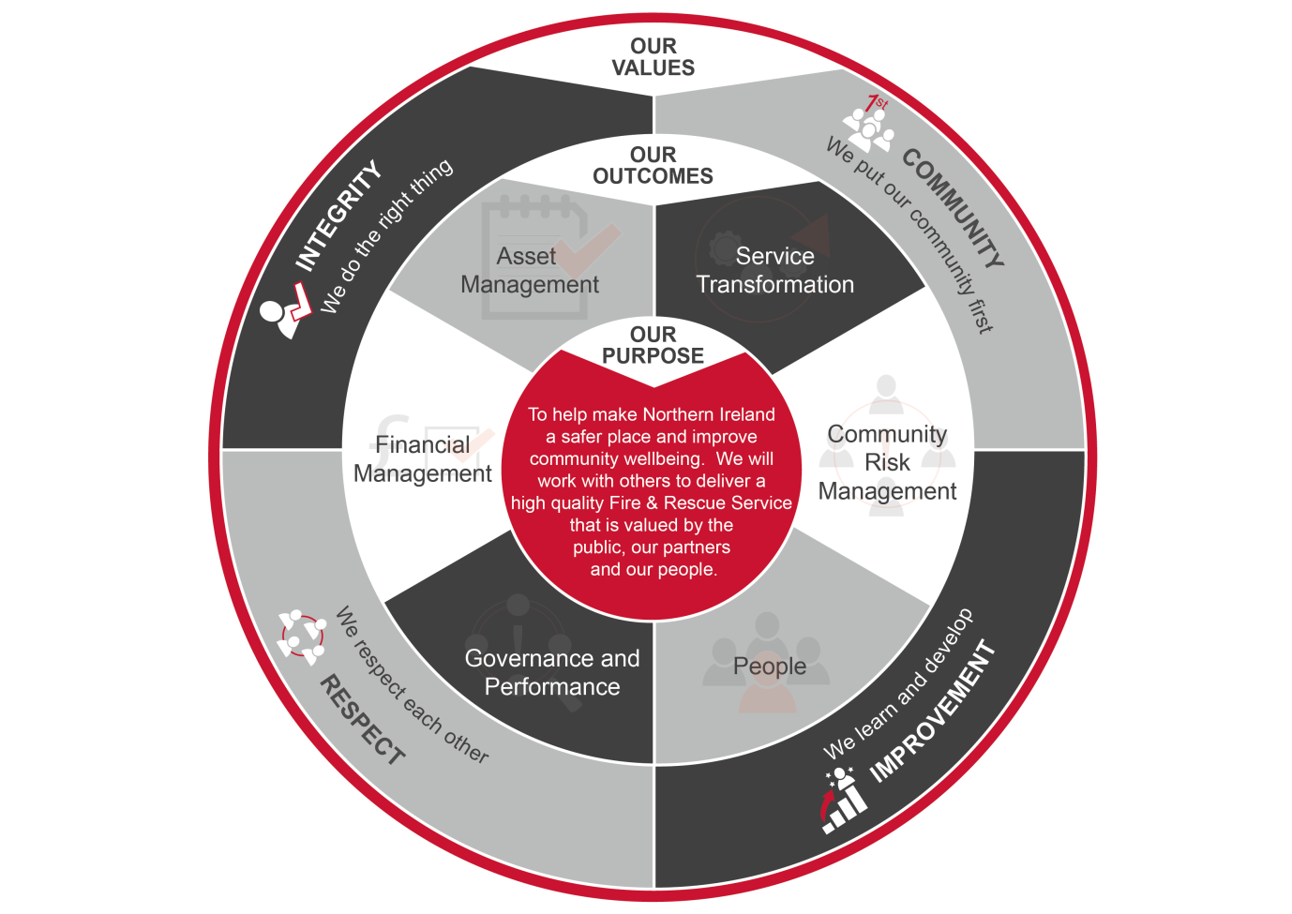

Summary of Responsibilities:
Payroll Services

- Responsible for the effective and efficient management of the Payroll Services Team and systems, ensuring the timely processing of payroll in compliance with internal policies, legislation, scheme of delegated authority, best practice and national/local terms and conditions of employment.

- To manage the team according to the principles of performance management, attendance management and personal development; and organise and prioritise workloads for the teams to ensure that processing deadlines are met.

- Manage and co-ordinate a training programme for new starts.

- Monitor and review staffing levels to ensure adequate provision of service and delegate the appropriate responsibility and authority to the level of staff with his/her control consistent with effective decision making whilst retaining responsibility and accountability for results.

- Responsible for the preparation of internal and external statutory returns as required to ensure compliance with legislation, financial instructions, scheme of delegated authority, policies, procedures and best practice.

- To perform reasonableness tests on payroll system outputs by using scanning analytics, and comparison tests with manually performed complex calculations.

- To perform a monthly payroll reconciliation by analysing data, checking and reconciling payroll information and making calculations.

- Development and implementation of policies, procedures and guidance to provide assurance on high standards of corporate governance.

- Responsible for ensuring that NIFRS employees are paid accurately and on time and that all month end/year end deadlines are complied with on a timely and accurate basis to assist in the preparation of Financial and Management Accounts and other statutory returns.

- Accountable for the accuracy and integrity of payroll records, including responsibility for authorising the provision of accurate pensionable pay information to the pension administrator.

- Monitor payroll bank accounts to ensure sufficient funds are available to meet business needs. This includes responsibility for accessing NIFRS online banking.

- Review and authorise payments within predetermined limits and set-up and transmit BACS payments as required.

- Maintain an up-to-date knowledge of developments across a broad range of payroll related activity to include changes to Departmental directives, policies, regulations, legislation, national/local terms and conditions of employment and work with managers to implement changes accordingly.

- Provide specialist advice and guidance to management on complex payroll matters.

- To provide a high level of internal and external customer service including taking ownership of customer queries and complaints and following issues through to completion.

- Lead the payroll team in the analysis, investigation and resolution of service requests, queries and discrepancies.

- Responsible for the recovery of overpaid salary, including notification to affected employees and negotiation of recovery arrangements.

- To maintain good relationships and morale amongst the wider finance team.

- Support the Management Accounting team in budgetary monitoring and variance reporting.

- Develop and maintain a sound knowledge of the structures and functions of the NIFRS and associated cost management and budget structure.

Governance, Data & Information Assurance
- Responsible for handling sensitive personal data and ensuring that the requirements of the General Data Protection Regulation (GDPR) are met.

- Key point of contact for internal / external audit queries and testing relating to payroll.

- Ensure that all audit recommendations are successfully managed and that all risks are identified and mitigated appropriately to maintain high standards of corporate governance.

- To monitor and report against the relevant performance indicators in relation to the management of the payroll services team, including regular data quality checks.

- Responsible for the development and maintenance of the payroll business continuity plan.

- To report any instances of fraud or potential frauds in line with policy to ensure compliance with the National Fraud Initiative

- To provide input to Assembly Questions and requests under Freedom of Information as required.

- Responsible for the development and implementation of a records management framework for payroll records, including a retention and disposal schedule and ensure appropriate disposal arrangements are in place.

- Mitigate financial risk by ensuring an effective and efficient controls framework is in place within the unit, including robust audit trail and appropriate approvals and the delivery of a spot checking / audit function for payroll claims.

- Provide a structure for utilising the document storage system that ensures that all payroll information can be readily and easily accessed by the Payroll Team members and relevant stakeholders such as internal / external audit.

Systems and Service Improvement
- To play a key role in the NIFRS Service Improvement Programme by leading on the migration of existing payroll services into new software systems and processes.

- Develop and maintain a list of known service issues, ensuring appropriate actions are in place to support issues resolution.

- Ensure the development of, and lead on, innovative and effective systems and procedures to achieve continuous improvement, customer journey improvements and improved reporting suite.

- Manage the external software suppliers to develop and deliver the systems in accordance with legislative and organisational requirements, whilst protecting the integrity and security of the payroll data and systems.

- Responsible for the sign-off of User Acceptance Testing following the implementation of payroll system changes.

- To assist in the preparation of appropriate business cases, tenders and quotations in line with financial and procurement regulations, policies and procedures and corporate timescales.

General responsibilities
- To ensure continued and effective working relationships with key stakeholders such as Heads of Department, Group Commanders, Area Business Managers and representative bodies.

- To provide support and cover as far as practicable for the others within the Finance department. This includes providing cover for service areas other than that initially assigned.

- To direct queries to the appropriate source for issues outside the remit of this post.

- To undertake project work as directed by the Financial Services Accountant using the principles of good project management and to represent the Financial Services Accountant as required.

- To participate as directed in the NIFRS recruitment and selection procedures, in line with NIFRS Code of Practice on Recruitment and Selection.

- To undertake the duties in such a way as to enhance and protect the reputation and public profile of the NIFRS.

- To be responsible for promoting, upholding and implementing all relevant NIFRS policies, plans and procedures and those relating to legal requirements such as equality, health and safety, data protection and freedom of information, etc.

- To undertake any other duties which may be assigned to meet organisational need and the change agenda and which are reasonably regarded as within the nature of the duties, responsibilities and grade of the post as defined.

Person Specification
Applicants must provide evidence by the closing date for application that they meet the following essential criteria:
Criteria | Essential/  Desirable |  | When Assessed

Knowledge, Skills and Experience
- Possess a degree or equivalent level qualification in a business-related subject, ie, Payroll or accountancy - CIPP, CCAB or AAT;  AND  Have at least two years’ experience working at a supervisory level in a payroll function within a complex large organisation, multi-site and multi-disciplinary *, to include:  - providing specialist advice on payroll issues including implementation of legislative and statutory payments;  - using integrated payroll software systems.  OR  - Possess a minimum of five years’ experience working in a payroll function within a complex large organisation, multi-site and multi-disciplinary *, to include:  - at least two years’ at supervisory level;  - providing specialist advice on payroll issues including implementation of legislative and statutory payments;  - using integrated payroll software systems. |  | Essential | Application Form/ Pre-employment check

Knowledge, Skills and Experience continued
- Have at least two years’ experience of managing a team to deliver results within a target driven environment, planning workloads, defining objectives, achieving deadlines and implementing action plans.  - Can demonstrate:  - excellent planning and organisational skills;  - deliver high quality work with excellent attention to detail;  - excellent communication skills (both oral and written) and the ability to advise and influence senior management;  - a strong customer orientation.  - Competent in the use of Windows and other Microsoft applications. |  | Essential  Essential  Essential | Application Form / Assessment/ Interview  Assessment/ Interview  Application Form/ Assessment/ Interview

Other Requirements
- Possess a full, current UK driving licence or have access to a form of transport which enables them to fulfil the full requirements of the job. | Essential |  | Application Form/ Pre-employment checks

Desirable
- Have experience of working within local government or the public sector.  - Have knowledge of National Joint Council Conditions of Service. | Desirable  Desirable |  | Application Form  Application Form

*NIFRS employs in excess of 2000 staff, has over 70 sites and a budget of circa £100 million

