Hosting Proforma
Department of Education

Name of Host
Organisation

1. Interchange Manager’s details
John McConnell
Name

Organisation/
RAISE Implementation Team
Department
Rathgael House
Balloo Road
Bangor
BT19 7PR

Address

Telephone Fax number
028 9127 9252

Number
John.McConnell@education-ni.gov.uk

E-mail

Type of Opportunity
Part of the RAISE Delivery Team – Project Governance – Executive Officer II (or equivalent) x 4

2. Details of hosting opportunity

Description of opportunity

The Department of Education is responsible for strategic policy direction, finance and legislation for schools and the youth service in Northern Ireland. This position is within a new RAISE Programme Implementation Team within the Raising Aspirations, Supporting Learning and Empowering Improvement Directorate. This new post is being created to ensure delivery of RAISE programme, which was a recommendation of the report “A Fair Start” published on 1 June 2021 by the Expert Panel on educational underachievement.

The RAISE programme is a key Departmental programme, which is funded by the Irish Government through the Shared Island funding initiative. Funding is confirmed for two years and agreed in principle for a further two years subject to Ministerial agreement. The programme has a substantial budget of around £8.5m per annum for RAISE and a further £1.5m p.a. for 2 supporting programmes entitled BLAST and T-REX.

Programme Background
The Department of Education is embarking on a transformative and innovative new programme of work. The RAISE programme is a whole community and place-based approach in eighteen areas across Northern Ireland to support the Department’s vision that “every child is happy, learning and succeeding”. It helps to deliver on the mission, set by the report ‘A Fair Start’, to ensure all children and young people regardless of background are given the best start in life.

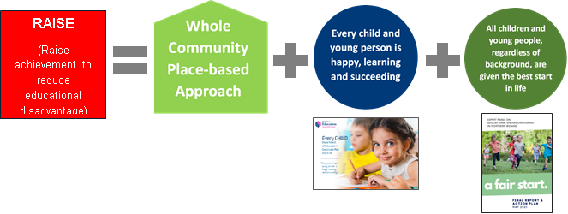

A Fair Start’ was published in 2021 by an Expert Panel examining the link between educational underachievement and socio-economic background. Its goals included drawing up an Action Plan for change to “ensure all children and young people, regardless of background are given the best start in life”. The Panel advocated that addressing educational underachievement “means placing equality of opportunity at the core of everything we do”.

A substantial investment by Shared Island of c£20m over 2 years (with the possibility of 2 further years funding) will include support to codesign strategic plans in each locality, with delivery being rolled out via community-informed projects as well as cross-cutting initiatives which can span, connect and share learning across localities, regionally and on an all-island basis. This requires partnerships and on-the-ground working relationships with organisations and communities across these localities. This requires engagement and the establishment of partnerships with children/youth organisations, families, communities and schools across localities through having a visible presence.

This approach matters because a child spends only around 14% of their lives until adulthood in a classroom and compulsory education. Schools nevertheless play a pivotal role in the lives of our children and young people, but they require support to meet the holistic needs of their pupils, all of which impact on their learning but some of which are outside the scope of a school’s remit.

A whole community approach to education extends beyond the school gate and means children and young people are supported in all contexts in which their lives are lived. It recognises a learning and support continuum for children and families/carers, from pre-birth through to young adulthood, and multiple pathways that can be available.

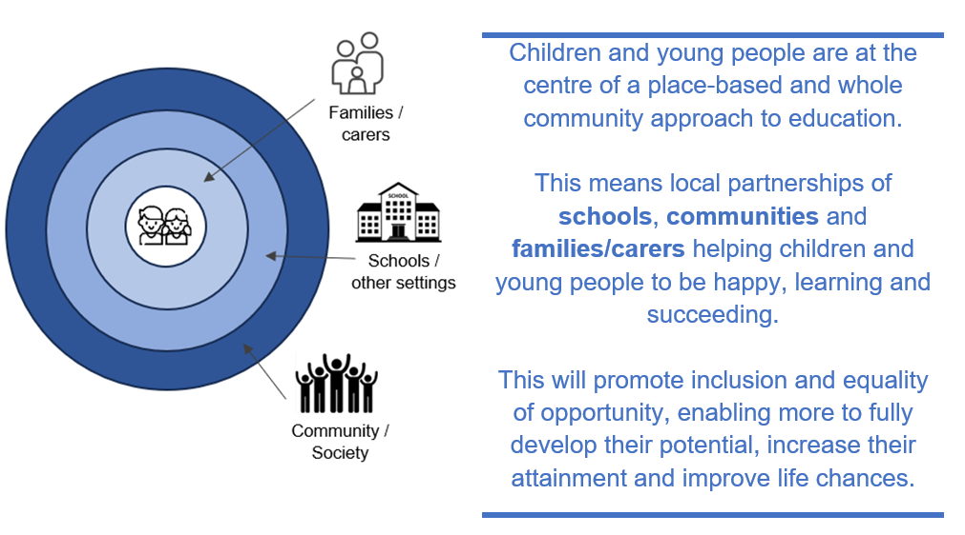

The Programme design applies a child centred, community informed and inclusion focused lens to the design and delivery of educational initiatives which are area based and in localities identified based on need.

This involves a bespoke local Strategic Plan for each place, codesigned by schools, children, families and community and others with a role to play in supporting children’s learning in the communities in these localities.

Collaboration enabled by these plans will build on good practice, test innovative approaches and identify and enhance pathways which promote equality of opportunity for those who face barriers to their learning and are at risk of exclusion, marginalisation and under-achievement.

The programme will run initially for 2 years and potentially extend for a further 2 years subject to evaluation. Learning from the RAISE programme will inform policy development and better ways of working together to realise the vision of every child is happy, learning and succeeding. An Advisory / Expert Panel comprising experts and practitioners will be established to support this goal.

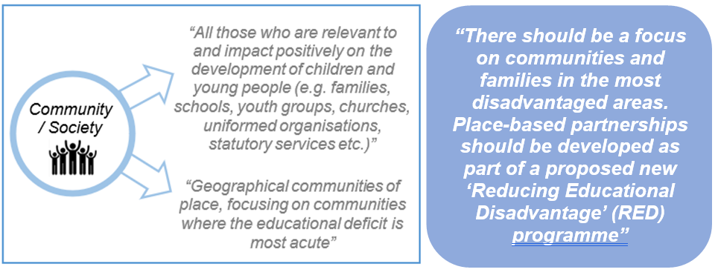

The Department of Education as the responsible Department is seeking to establish a Delivery Team with a range of different skills and expertise. This is an exciting opportunity to be involved from the inception of a transformational programme in education to help shape, design and implement which will impact on the lives of children and young people. This team requires a mix of experience including programme management, locality engagement & relationship building, communications research & evaluation and administrative roles.
The post holder will be part of a team responsible for a wide range of activities in support of the implementation of the RAISE Programme, including programme governance, oversight, monitoring, reporting and evaluation.

Main objectives of the opportunity

The main duties and responsibilities of the post are to:
- Provide administrative support to regular meetings of the various elements of the governance structures (Programme Board, Advisory Forum, Addressing Disadvantage Learning and Research Board etc).
- Deliver specific procurement activities to support delivery of RAISE cross-cutting projects, communication/branding, engagement with children and young people and families, and independent evaluation of the programme.
- Deliver specific activities with regard to the delivery of grant funding for community-led projects.
- Collate financial monitoring data to ensure spend is progressing against profile and any underspends are highlighted in a timely manner.
- Collate delivery data to support the monitoring of programme implementation and evaluation of outcomes/impact.
- Monitor AQs, INVs, CORs etc using the Team Tracker.
- Support the team to draft and provide input to timely and accurate updates to Minister, Executive, Education Committee, FM, dFM, MLAs, schools, public, and correspondence cases.
- Support the team to draft replies to Assembly Questions, Ministerial cases, Secretary’s Cases and senior management/internal and external stakeholder queries within specified deadlines.
- Support the team to draft written and oral briefing and advice to branch management, Senior Management Team, Minister as appropriate.
- Support team members with other work areas as required.

3. Skills requirements

What qualities, skills and experience is required from the individual

The required knowledge, experience and skills should include:

- Organisation skills – Planning and reporting upon work, meeting deadlines, identifying and highlighting risks.
- Networking - ability to develop and maintain networks as appropriate with stakeholders inside and outside the department.
- Communication – accurate, concise and clear communication required with team members and customers.
- Policy ability – contribute to the development and implementation of policy.
- Management ability – organising use of human and other resources to best effect.
- Analytical ability – analyse and evaluate problems logically and quickly and make sound decisions/recommendations.
- Numerical skills - i.e. collation of data / budget monitoring / use of spreadsheets.
- IT skills – frequent use of spreadsheets (Excel) and extensive use of Word, Powerpoint and email.

4. Personnel: Please state below

Who will the individual report to?
New Role – Staff Officer – RAISE Implementation team

Who will be the individual’s line manager and/or reporting officer?
New Role – Staff Officer – RAISE Implementation team

5. Transfer of learning
Please give details of how the Opportunity will benefit your organisation, the
individual and their organisation.

Benefits for DE
The Department of Education is embarking on a transformative and innovative new programme of work. The RAISE programme is a whole community and place-based approach in eighteen areas across Northern Ireland to support the Department’s vision that “every child is happy, learning and succeeding”. It helps to deliver on the mission, set by the report ‘A Fair Start’, to ensure all children and young people regardless of background are given the best start in life

Benefits for other departments
Increasingly, there is a need within the public sector to collaborate with colleagues in other departments, local government and external agencies, in order to maximise the resources available, deliver collective impact and to ensure that the requirements asked of the school / V&C sector are clear and consistent. Lessons learnt as part of this process will be helpful in informing what happens in other departments and to inform future policy and delivery

Benefits for the applicant
This post offers the applicant the opportunity to develop the full range of competencies at this level i.e. Setting Direction, Engaging People and Delivering Results. It offers a unique opportunity to work in a new and transformational programme with localities on the ground to effect change and see the impact of the programmes and policies and investment and influence departmental policy as a result.

6. Logistics
Please provide details of the likely start date, duration, location, form of transport required, resources (i.e.; desk, PC, etc.) and funding arrangements for the opportunity.

Start Date: April / May 2025

Duration: 2 years with the possibility of a further 2 years.

Location: Rathgael House, Balloo Road, Bangor, BT19 7PR, however, hybrid working arrangements will be available.

Resources: People and Funding

Funding: Costs for the post will be met by DE and the salary scale is: £27,897 - £28,483.

Further information: please contact John McConnell at John.McConnell@education-ni.gov.uk or Patrick Anderson at Patrick.Anderson@education-ni.gov.uk

Closing Date: Applications* must be submitted by 5.00pm on Friday 28 February 2025
For staff from Interchange member organisations: interchangesecretariat@finance-ni.gov.uk

*This opportunity is not open to NI Civil Service staff

7. Endorsement

Interchange Manager

Signed:
C McClelland

Date:
15.01.25

