Hosting Proforma
Northern Ireland Fire and Rescue Service

Name of Host
Organisation

1. Interchange Manager’s details
Shirley McDonnell
Name

Organisation/
Northern Ireland Fire and Rescue Service
Department
NIFRS Headquarters
1 Seymour Street
Lisburn
BT27 4SX
Address

Telephone Fax number
028 92 664221

Number
Shirley.McDonnell@nifrs.org

E-mail

Fixed Term Contract – Three Years

Type of Opportunity

2. Details of hosting opportunity

Description of opportunity

HR Manager, Resourcing and Employee Services

The Northern Ireland Fire & Rescue Service (NIFRS) protects and serves the entire population of Northern Ireland, an area of over 5,500 square miles and with a population of 1.9 million, providing them with a range of fire and rescue services.

The HR Manager, Resourcing and Employee Services will be responsible for the effective and efficient management of the resourcing and employee services teams, including workforce planning, recruitment, selection, appointment, transfers and promotions and the provision of related proactive, specialist support and advice.

A full Job Description and Person Specification is at Annex 1

Main objectives of the opportunity

The post holder will contribute as an integral member of the HR team to the provision of a modern, professional and responsive HR service to support the vision and mission of NIFRS.

Key areas of the role will include demonstrating proven Human Resourcing knowledge and organisation skills with regard to:

- Employee Recourcing
- Employee Services
- Performance and Financial Management
- And General management/responsibilities

Full Job Description and Person Specification attached in Appendix 1

3. Skills requirements

What qualities, skills and experience is required from the individual

Either:
- Hold a degree (Level 6) or equivalent level qualification in a relevant subject i.e. Human Resource Management, Business Studies etc
PLUS
Hold at least current Chartered membership of the Chartered Institute of Personnel and Development.Processing remuneration payments and other entitlements;

- Have at least 3 years’ experience working in a resourcing function in a large complex, multi-site, multi-disciplinary and unionised organisation.

- Possess a sound understanding of best practice and techniques for employee resourcing practice.

- Have a proven track record in the delivery of significant resourcing exercises.

Demonstrate:
- Experience using HR management information systems.
- excellent planning and organisational skills
- ability to work accurately under pressure of multiple deadlines
- strong interpersonal and influencing skills
- evidence of effectively leading and motivating a team
- a strong customer orientation
- fully conversant with current employment legislation relating to resourcing.
Other:
- Possess a full, current UK driving licence or have access to a form of transport which enables them to fulfil the full requirements of the job.

4. Personnel: Please state below

Who will the individual report to?
Assistant Director Human Resources Advisory Services

Who will be the individual’s line manager and/or reporting officer?
Assistant Director Human Resources Advisory Services

5. Transfer of learning
Please give details of how the Opportunity will benefit your organisation, the
individual and their organisation.

This is a fantastic opportunity for a suitably qualified and experienced individual to further their experience within NIFRS during a period of significant change and improvement.

6. Logistics
Please provide details of the likely start date, duration, location, form of transport required, resources (i.e.; desk, PC, etc.) and funding arrangements for the opportunity.

Start Date: As soon as a suitable candidate has been identified and a release date has been agreed.

Duration: Fixed Term Contract for Three Years with possible extension

Location: NIFRS Headquarters, 1 Seymour Street, LISBURN, BT27 4SX

Resources: This post is office based and all resources will be provided. There may be the opportunity for Hybrid Working however the post-holder will be expected to be flexible to meet the needs of the role.

Funding: NIFRS will meet the salary and associated costs for the role. The salary range is currently £47,754 to £50,788.

Further information: Process will consist of shortlisting during January 2025 and may be followed by interview if required, which will take place in February 2025. For further information please contact Shirley McDonnell on Tel: 028 9266 4221 or by email at: Shirley.McDonnell@nifrs.org

Closing Date: Applications must be submitted by Noon on Monday 27 January 2025 to:

For NI Civil Service departmental staff only: secondments@hrconnect.nigov.net

For staff from all other Partner organisations: interchangesecretariat@finance-ni.gov.uk

7. Endorsement

Interchange Manager

Signed:
Shirley McDonnell

Date:
06 January 2025

Job Description Annex 1
Reference Number: Interchange 03/25 Date: January 2025
Directorate: Human Resources
Department: Human Resources Advisory
Job Title: HR Manager, Resourcing and Employee Services
Grade: PO5
Reports to: Assistant Director Human Resources Advisory Services
MAIN PURPOSE
To be responsible for the effective and efficient management of the resourcing and employee services teams, including workforce planning, recruitment, selection, appointment, transfers and promotions and the provision of related proactive, specialist support and advice.
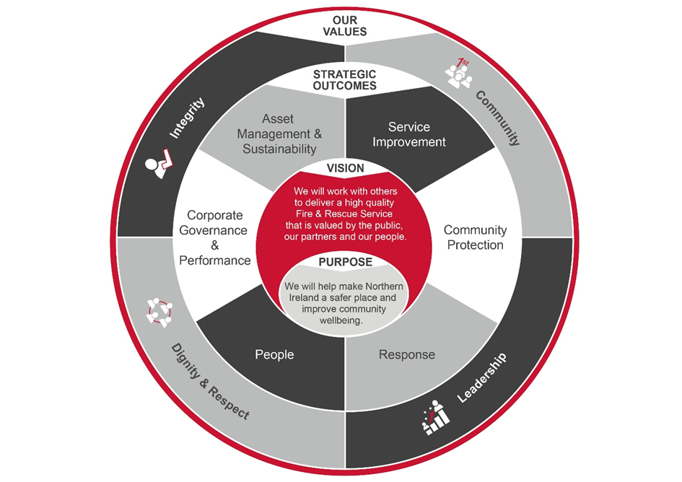
To contribute as an integral member of the HR team to the provision of a modern, professional and responsive HR service to support the vision and mission of NIFRS as outlined below:

Summary of Responsibilities:
Employee Resourcing:
- To manage the complete ‘life cycle’ for recruitment, selection, appointment, transfers or promotion for both internal and external appointments. This includes pre-employment checks, the design and development of tools and processes in line with national guidance and current employment legislation. It may also include working with external agencies and partners.

- To ensure the effective management of the HR Advisors (Resourcing) in the provision of proactive, specialist advice and support to senior managers of NIFRS on all recruitment, selection and promotion issues including managing cases as appropriate.

- To manage successful uniformed recruitment activity with a focus on the regular promotion cycles and whole-time uniformed recruitment including high profile campaigns in the UK and Ireland.

- To ensure successful employee resourcing activity for headquarters, area and NIFRS Learning and Development Centre support staff, retained fire-fighters and NIFRS senior posts.

- To work with key stakeholders (e.g. Operations and Establishment) to develop detailed resourcing plans.

- To work in partnership with the Organisation Development unit to schedule recruitment activity including contributing to the delivery of assessment centres and testing including preparatory work, conducting assessments and basic skills tests (written and numerical) as required.

- To keep up to date with latest developments in recruitment best practice and legislative requirements and ensure legal compliance.

- To provide guidance and support to shortlisting and interview panels – including participation in panels as required.

- To ensure the timely preparation and placing of advertisements for resourcing activity including liaison with internal and external stakeholders as required.

- To ensure all pre-employment checks are completed, and appointment letters are issued, on a timely basis
- To ensure all employees have terms and conditions of employment within the specified legal timeline.

- To manage the accurate and timely recording of all pertinent information in relation to employee resourcing activities including archiving and retention of relevant notes and files.

- To ensure effective and efficient working relationships with other HR team members, particularly the HR Business Partners.

- To take ownership and ensure closure for all queries including preparing responses to complaints or requests for feedback from candidates, dealing with public and legal representatives and ensuring compliance with Data Protection and Freedom of Information requests.

- To ensure continued and effective working relationships with key internal and external stakeholders such as Heads of Department, Group Commanders (P&T), Service Delivery Business Managers and representative bodies.

- To ensure the delivery of appropriate training on new and existing recruitment, selection and promotion policies for NIFRS employees in compliance with relevant legislation and guidance.

- To ensure the effective coordination of the approved job evaluation process for NIFRS support staff including participation in the process as required.

- To ensure the accurate and timely production of appropriate management information and statistics for statutory returns to the NIFRS board and corporate management team and appropriate authorities and agencies.

- To contribute as required to the development, implementation and review of new and existing HR policies in accordance with current and future legislation with particular responsibility for the code of procedures on recruitment and selection.

- To contribute to and develop HR strategy as required.

Employee Services:
- To manage the HR Advisor (Employee Services) to deal effectively with all HR transactional services including special leave, sickness, starters and leavers, equality monitoring etc. providing a robust service to HR colleagues and customers.

- To ensure the development and maintenance of effective working relationships with key stakeholders inside and outside the HR Directorate, particularly the Finance Directorate.

- To ensure the production of HR reports and management information to enable effective reporting to the customers, the corporate management team and NIFRS board.

- To ensure the range of services and activities undertaken by the Resourcing & Employee Services team are developed to incorporate best practice.
Performance and financial management:
- To be responsible for the management of the Resourcing and Employee Services Teams including the development of all associated employees.

- To oversee the procurement, management and review of NIFRS-wide contracts, for example, employment agencies, job advertising, resourcing testing / assessment centres, and other relevant resourcing activities

- To be responsible and accountable for monitoring and managing the Employee Resourcing and Employee Services budget in line with financial and procurement regulations, policies and procedures and corporate timescales.

General management/responsibilities
- To provide support and cover as far as practicable for the other HR Managers.

- To contribute as required to the preparation of the HR strategy, business plan and associated action plans.

- To direct and signpost senior managers and officers to the appropriate source for issues outside the remit of this post. This includes providing cover for service areas other than that initially assigned.

- To undertake HR-related project work as directed by the Head of HR Advisory using the principles of good project management.

- To participate as directed in the NIFRS recruitment and selection procedures, chairing panels as required as the senior human resources department representative

- To undertake the duties in such a way as to enhance and protect the reputation and public profile of the NIFRS.

- To respond appropriately to all corporate governance requirements for example audit and risk register compliance.

- To maintain an up-to-date knowledge of developments across a broad range of HR-related activity to include changes to regulations, legislation and national/local terms and conditions of employment and maintain personal CPD.

- To be responsible for promoting, upholding and implementing all NIFRS policies, plans and procedures and those relating to legal requirements such as equality, health and safety, data protection and freedom of information, etc.

- To undertake any other duties which may be assigned to meet organisational need and the change agenda and which are reasonably regarded as within the nature of the duties, responsibilities and grade of the post as defined.

- To represent the Head of HR Advisory and the Director of Human Resources as required, including in the conduct of formal trade union consultation and negotiations.

Section 4: Person Specification
Applicants must provide evidence by the closing date for application that they meet the following essential criteria:
Criteria | Essential/  Desirable |  | When Assessed

Knowledge, Skills and Experience
- Hold a degree (Level 6) or equivalent level qualification in a relevant subject i.e. Human Resource Management, Business Studies etc;  - AND  - Hold at least current Chartered membership of the Chartered Institute of Personnel and Development. | Essential |  | Application Form/ Pre-employment checks

Knowledge, Skills and Experience continued
- Have at least 3 years’ experience working in a resourcing function in a large complex, multi-site, multi-disciplinary and unionised organisation.  - Possess a sound understanding of best practice and techniques for employee resourcing practice.  - Have a proven track record in the delivery of significant resourcing exercises.  - Experience using HR management information systems. |  | Essential | Application Form/ / Assessment / Interview

Knowledge, Skills and Experience continued
- Can demonstrate:  - excellent planning and organisational skills  - ability to work accurately under pressure of multiple deadlines  - strong interpersonal and influencing skills  - evidence of effectively leading and motivating a team  - a strong customer orientation  - fully conversant with current employment legislation relating to resourcing. | Essential | Assessment / Interview

Other Requirements
- Possess a full, current UK driving licence or have access to a form of transport which enables them to fulfil the full requirements of the job. | Essential | Application Form/ Pre-employment checks

Desirable
- Hold a Post-Graduate (Level 7) qualification in Human Resource Management or equivalent.  - Hold a Level A British Psychological Society (BPS) certificate in Occupational Testing. | Desirable | Application Form/ Pre-employment checks

