Hosting Proforma
Northern Ireland Fire and Rescue Service

Name of Host
Organisation

1. Interchange Manager’s details
Shirley McDonnell
Name

Organisation/
Northern Ireland Fire and Rescue Service
Department
NIFRS Headquarters
1 Seymour Street
Lisburn
BT27 4SX
Address

Telephone Fax number
028 92 664221

Number
Shirley.McDonnell@nifrs.org

E-mail

2 x Fixed Term Contracts – Three Years

Type of Opportunity

2. Details of hosting opportunity

Description of opportunity

HR Advisor (Resourcing) x 2 Posts

The Northern Ireland Fire & Rescue Service (NIFRS) protects and serves the entire population of Northern Ireland, an area of over 5,500 square miles and with a population of 1.9 million, providing them with a range of fire and rescue services.
The HR Advisor (Resourcing) is a vital role within the Resourcing Team. They will be responsible for effective delivery of resourcing exercises required by NIFRS.
The HR Advisor will support the relevant HR Manager to ensure effective and efficient delivery of the relevant service within NIFRS and will contribute as an integral member of the HR team to the provision of a modern, professional and responsive HR service.
There are currently two fixed term posts, for a period of 3 years, based at NIFRS HQ in Lisburn.

A full Job Description and Person Specification are at Annex 1.

Main objectives of the opportunity

The post holder will contribute as an integral member of the HR team to the provision of a modern, professional and responsive HR service to support the vision and mission of NIFRS.

Key areas of the role will include demonstrating proven Human Resourcing knowledge and administrative skills with regard to:

- Managing Recruitment campaigns, including advertisements, shortlisting, interviewing, issuing correspondence and pre-employment checks
- Providing advice and guidance in line with relevant legislation and HR best practice
- Prepare responses to SARs/FOIs
- Records Management
- Proving recruitment and selection training
- Information Management
Full Job Description and Person Specification attached in Appendix 1

3. Skills requirements

What qualities, skills and experience is required from the individual

Either:
- Hold a a minimum of a Level 5 qualification in a business related subject; AND
Be a current member of the of the Chartered Institute of Personnel & Development (CIPD); AND

Have at least two years’ experience of working in employee resourcing within a large, multi-site, multi-disciplinary organisation

OR

- Have at least four years’ experience of working in employee resourcing within a large, multi-site, multi-disciplinary organisation; AND
Hold or be working towards achieving Chartered Institute of Personnel & Development (CIPD) membership
Demonstrate:
- Experience of providing professional HR advice to shortlisting and interview panels to a senior level within an organisation
- a sound understanding of current employment legislation relating to employee resourcing
- excellent planning, organisation, prioritising skills and attention to detail
- good communication skills (both oral and written) and the ability to advise and influence senior management
Other:
- Possess a full, current UK driving licence or have access to a form of transport which enables them to fulfil the full requirements of the job.

4. Personnel: Please state below

Who will the individual report to?
HR Manager, Resourcing & Employee Services

Who will be the individual’s line manager and/or reporting officer?
HR Manager, Resourcing & Employee Services

5. Transfer of learning
Please give details of how the Opportunity will benefit your organisation, the
individual and their organisation.

This is a fantastic opportunity for a suitably qualified and experienced individual to further their experience within NIFRS during a period of significant change and improvement.

6. Logistics
Please provide details of the likely start date, duration, location, form of transport required, resources (i.e.; desk, PC, etc.) and funding arrangements for the opportunity.

Start Date: As soon as a suitable candidate has been identified and a release date has been agreed.

Duration: 2 x Fixed Term Contracts for Three Years.

Location: NIFRS Headquarters, 1 Seymour Street, LISBURN, BT27 4SX

Resources: This post is office based and all resources will be provided. There may be the opportunity for Hybrid Working however the post-holder will be expected to be flexible to meet the needs of the role.

Funding: NIFRS will meet the salary and associated costs for the role. The salary range is currently £36,124 to £37,938.

Further information: Process will consist of shortlisting during January 2025 and may be followed by interview if required, which will take place in February 2025. For further information please contact Shirley McDonnell on Tel: 028 9266 4221 or by email at: Shirley.McDonnell@nifrs.org

Closing Date: Applications must be submitted by Noon on Monday 27 January 2025 to:

For NI Civil Service departmental staff only: secondments@hrconnect.nigov.net

For staff from all other member organisations: interchangesecretariat@finance-ni.gov.uk

7. Endorsement

Interchange Manager

Signed:
Shirley McDonnell

Date:
06 January 2025

Section 3: Job Description Annex 1
Reference Number: I/C 03/25 Date: January 2025
Directorate: Human Resources
Department: Human Resources (Resourcing)
Job Title: HR Advisor (Resourcing)
Grade: SO2
Reports to: HR Manager, Resourcing & Employee Services
MAIN PURPOSE
To ensure the effective delivery of resourcing exercises required by NIFRS, with a particular focus on uniformed recruitment and promotion.

To contribute as an integral member of the HR team to the provision of a modern, professional and responsive HR service to support the vision and mission of NIFRS as outlined below:
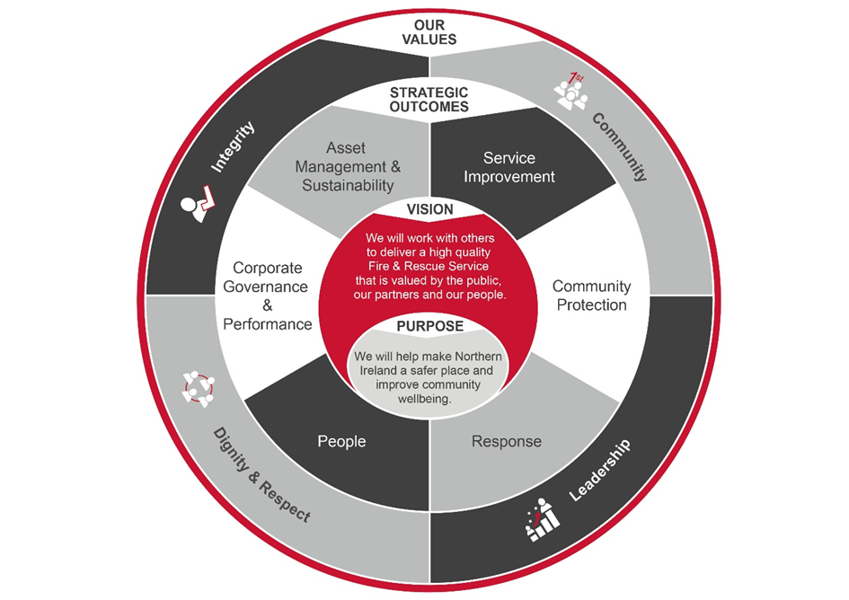

Summary of Responsibilities:
1. To ensure the successful delivery of any resourcing and promotions activity assigned in accordance with the NIFRS Code of Procedures on Recruitment and Selection, relevant legislation and HR best practice.

2. To take a lead role on uniformed resourcing/promotion cycles including high profile campaigns throughout the UK and Ireland.

3. To liaise regularly with the Organisation Development Unit to schedule resourcing activity and contribute to assessment and testing as required.

4. To ensure effective communication with candidates and panels before, during and after resourcing activities.

5. To ensure the timely delivery of all pre-employment checks including medicals, references and Access NI checks.

6. To produce accurate and timely correspondence, eg, offer letters for candidates as required.

7. To provide guidance and support to shortlisting and interview panels – including appropriate participation as required.

8. To ensure the timely preparation and setting of advertisements for resourcing exercises.

9. To prepare responses to complaints or requests for feedback from candidates, public and legal representatives for final agreement by the HR Manager, Resourcing and Employee Services.

10. To prepare responses to Freedom of Information and Data Protection requests, Ministerial, Parliamentary or NI Assembly questions; liaising with internal and external stakeholders as required.

11. To issue employees with their contracts of employment within the specified legal timeframe.

12. To record in a timely and accurate manner all pertinent information in relation to employee resourcing activities including archiving and retention of relevant notes and files.

13. To keep up-to-date with the latest developments in recruitment best practice and legislation.

14. To ensure effective working relationships with other HR employees and units particularly the HR Business Partners and Employee Services.

15. To ensure continued and effective working relationships with key stakeholders such as heads of department, Group Commanders (Personnel & Training), Area Business Managers and representative bodies.

16. To provide suitable training for NIFRS staff in recruitment and selection procedures and techniques as required.

17. To produce HR reports on employee resourcing activities and outcomes as required.

18. To direct and signpost managers and officers to the appropriate source for issues outside the remit of this post. This includes providing cover for service areas other than that initially assigned.

19. To undertake HR-related project work as directed by the HR Manager, Resourcing and Employee Services using the principles of good project management.

General management/responsibilities
20. To prepare business cases, tenders and quotations in line with financial and procurement regulations, policies and procedures and corporate timescales.

21. To participate as directed in the NIFRS recruitment and selection procedures.

22. To maintain an up-to-date knowledge of organisational policies and procedures impacting on HR activity at both a corporate and local level.

23. To undertake the duties in such a way as to enhance and protect the reputation and public profile of the NIFRS.

24. To maintain an up-to-date knowledge of developments across a broad range of HR-related activity to include changes to regulations, legislation and national/local terms and conditions of employment (Continuing Professional Development).

25. To be responsible for promoting, upholding and implementing all NIFRS policies, plans and procedures and those relating to legal requirements such as equality, health and safety, data protection and freedom of information, etc.

26. To undertake any other duties which may be assigned to meet organisational need and the change agenda and which are reasonably regarded as within the nature of the duties, responsibilities and grade of the post as defined.

Section 4: Person Specification
Applicants must provide evidence by the closing date for application that they meet the following essential criteria:
Criteria | Essential/  Desirable |  | When Assessed

Knowledge, Skills and Experience
- Hold a minimum of a Level 5 qualification* in a business related subject; and  - Be a current member of the Chartered Institute of Personnel & Development (CIPD); and  - Have at least two years’ experience of working in employee resourcing within a large, multi-site, multi-disciplinary organisation  - *Examples of Level 5 qualifications include but are not limited to; Diploma of Higher Education (DipHE), Foundation Degree, Higher National Diploma (HND), Level 5 Award, Level 5 Certificate, Level 5 Diploma, Level 5 NVQ.  - OR:  - Have at least four years’ experience of working in employee resourcing within a large, multi-site, multi-disciplinary organisation; and  - Hold or be working towards achieving Chartered Institute of Personnel & Development (CIPD) membership. | Essential |  | Application Form/ Assessment /Interview/Pre-employment Check

Knowledge, Skills and Experience continued
- Have experience of providing professional HR advice to shortlisting and interview panels to a senior level within an organisation.  - Have a sound understanding of current employment legislation relating to employee resourcing.  - Can demonstrate:  - (a) excellent planning, organisation, prioritising skills and attention to detail;  - (b) good communication skills (both oral and written) and the ability to advise and influence senior management. |  | Essential | Application Form/ Assessment /Interview

Other Requirements
- Possess a full, current UK driving licence or have access to a form of transport which enables them to fulfil the full requirements of the job | Essential |  | Application Form/ Pre-employment checks

Desirable
- Have experience in planning and leading a major recruitment drive.  - Have experience of responding to complaints or enquiries from candidates, members of the public, legal and public representatives.  - Have experience of working within local government or the public sector. | Desirable |  | Application Form/ Assessment /Interview

