Hosting Proforma
Department of Education

Name of Host
Organisation

1. Interchange Manager’s details
Peter Hutchinson
Name

Organisation/
Raising Aspiration, Supporting Learning Empowering Improvement
Department
Rathgael House
Balloo Road
Bangor
BT19 7PR
Address

02891 858022

Telephone Fax number
N/A
Number
peter.hutchinson@education-ni.gov.uk

E-mail

Type of Opportunity
Part of the RAISE Delivery Team – Programme Communications and Community Engagement Lead

2. Details of hosting opportunity

Description of opportunity


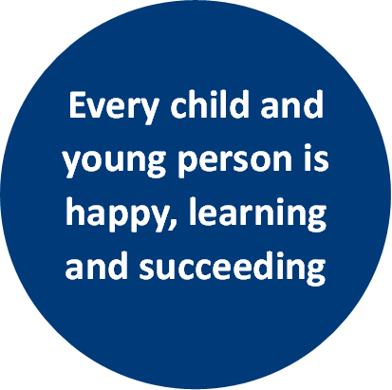
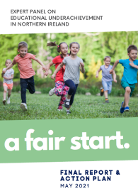
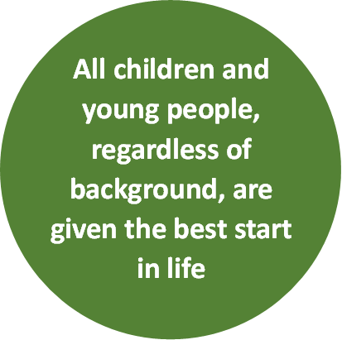
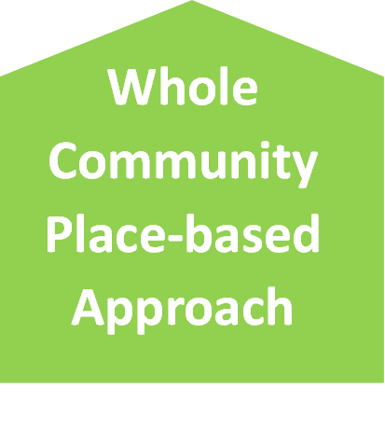
- The Department of Education is embarking on a transformative and innovative new programme of work. The RAISE programme is a whole community and place-based approach in eighteen areas across Northern Ireland to support the Department of Education’s vision that “every child is happy, learning and succeeding”. It helps to deliver on the mission, set by the report ‘A Fair Start’, to ensure all children and young people regardless of background are given the best start in life.
RAISE
(Raise achievement to reduce educational disadvantage)

- A Fair Start’ was published in 2021 by an Expert Panel examining the link between educational underachievement and socio-economic background. Its goals included drawing up an Action Plan for change to “ensure all children and young people, regardless of background are given the best start in life”. The Panel advocated that addressing educational underachievement “means placing equality of opportunity at the core of everything we do”.

- A substantial investment by Shared Island of c£20m over 2 years (with the possibility of 2 further years funding) will include support to codesign strategic plans in each locality, with delivery being rolled out via community-informed projects as well as cross-cutting initiatives which can span, connect and share learning across localities, regionally and on an all-island basis. This requires partnerships and on-the-ground working relationships with organisations and communities across these localities. This requires engagement and the establishment of partnerships with children/youth organisations, families, communities and schools across localities through having a visible presence.

- This approach matters because a child spends only around 14% of their lives until adulthood in a classroom and compulsory education. Schools nevertheless play a pivotal role in the lives of our children and young people but they require support to meet the holistic needs of their pupils, all of which impact on their learning but some of which are outside the scope of a school’s remit.

- A whole community approach to education extends beyond the school gate and means children and young people are supported in all contexts in which their lives are lived. It recognises a learning and support continuum for children and families/carers, from pre-birth through to young adulthood, and multiple pathways that can be available.
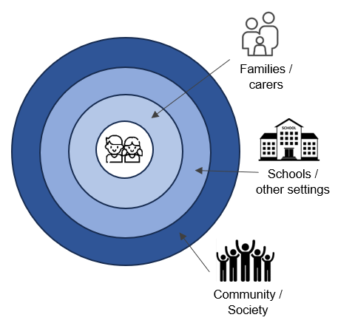
Children and young people are at the centre of a place-based and whole community approach to education.

This means local partnerships of schools, communities and families/carers helping children and young people to be happy, learning and succeeding.

This will promote inclusion and equality of opportunity, enabling more to fully develop their potential, increase their attainment and improve life chances.

- The Programme design applies a child centred, community informed and inclusion focused lens to the design and delivery of educational initiatives which are area based and in localities identified based on need.

- This involves a bespoke local Strategic Plan for each place, codesigned by schools, children, families and community and others with a role to play in supporting children’s learning in the communities in these localities.

- Collaboration enabled by these plans will build on good practice, test innovative approaches and identify and enhance pathways which promote equality of opportunity for those who face barriers to their learning and are at risk of exclusion, marginalisation and under-achievement.

- The programme will run initially for 2 years (starting in 2024) and potentially extend for a further 2 years subject to evaluation. Learning from the RAISE programme will inform policy development and better ways of working together to realise the vision of every child is happy, learning and succeeding. An Advisory / Expert Panel comprising experts and practitioners will be established to support this goal.

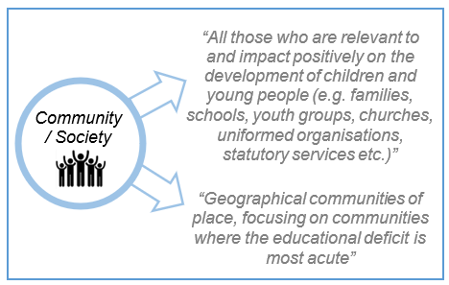
“There should be a focus on communities and families in the most disadvantaged areas. Place-based partnerships should be developed as part of a proposed new ‘Reducing Educational Disadvantage’ (RED) programme”

- The Department of Education as the responsible Department is seeking to establish a Delivery Team with a range of different skills and expertise. This is an exciting opportunity to be involved from the inception of a transformational programme in education to help shape, design and implement which will impact on the lives of children and young people. This team requires a mix of experience including programme management, locality engagement & relationship building, communications research & evaluation and administrative roles.

- The Communications and Engagement Lead will play a key part in the success of the delivery of RAISE at a local, regional and national level. The post holder will be responsible for leading a number of staff across eighteen localities in NI, articulating what RAISE is about, what it means for localities, the children, families and communities who live there and how they can effect change.

Main objectives of the opportunity

The Programme Communications and Community Engagement Lead will report to the RAISE Programme Director (G5).

It is envisaged that the Programme Communications and Community Engagement Lead will plan, design and deliver a RAISE Community Engagement Strategy and a RAISE Communications Strategy and manage the work of Community Engagement Officers.

The main responsibilities of Programme Communications and Community Engagement Lead will be:
- Setting a vision for the RAISE programme and communicating it at a strategic level.
- Working with Programme Manager and Local Co-ordinators to provide innovative and effective approaches to community engagement and co-design.
- Developing and delivering innovative communication and engagement approaches to promoting RAISE, ensuring “hard to reach” groups are included.
- Supporting the development of RAISE Strategic Plans and roll-out from a communications and engagement perspective.
- RAISE event management.
- Oversee all internal and external communications in line with the Community Engagement/Communications Strategy.
- Political engagement on Programme issues as necessary.
- Manage the content for internal and external communications – speeches, briefings, newsletters, digital communications, press releases and responses to media enquiries.
- Preparing and disseminating promotional and press material relating to projects in conjunction with EIS.
- Manage the Communication and Public Relations/Affairs activities in line with the Communication & Community Engagement Strategy.
- Work with the Programme Manager and Local Co-ordinators to maximise opportunities for engagement and PR through local activities.
- Take on any other additional responsibilities required by the Programme Director / DE.

3. Skills requirements

What qualities, skills and experience are required from the individual

Essential Skills & Experience
- Experience in a communications role of a strategic programme (with significant reach).
- A proven ability to successfully prioritise and deliver a busy programme of work;
- Demonstrable experience of planning, managing and evaluating communication plans;
- Demonstrable experience of managing complex media queries;
- A proven ability to write and edit information so that it is accurate, clear and concise for an intended audience;
- A high level of verbal communication skills;
- A proven ability to establish and maintain productive working relationships with internal and external stakeholders at a range of levels; and
- A high level of literacy using a range of Microsoft Office applications.
- The ability to organise and prioritise own workload, work on own initiative and to take responsibility for delivery of high quality results to tight deadlines is required.

4. Personnel: Please state below

Who will the individual report to?
Director of Raising Aspiration, Supporting Learning and Empowering Improvement (DE)

Who will be the individual’s line manager and/or reporting officer?
Director of Raising Aspiration, Supporting Learning and Empowering Improvement (DE)

5. Transfer of learning
Please give details of how the Opportunity will benefit your organisation, the
individual and their organisation.

Benefits for DE
The Department of Education is embarking on a transformative and innovative new programme of work. The RAISE programme is a whole community and place-based approach in eighteen areas across Northern Ireland to support the Department’s vision that “every child is happy, learning and succeeding”. It helps to deliver on the mission, set by the report ‘A Fair Start’, to ensure all children and young people regardless of background are given the best start in life.

Benefits for other departments
Increasingly, there is a need within the public sector to collaborate with colleagues in other departments, local government and external agencies, in order to maximise the resources available, deliver collective impact and to ensure that the requirements asked of the school / V&C sector are clear and consistent. Lessons learnt as part of this process will be helpful in informing what happens in other departments and to inform future policy and delivery.

Benefits for the applicant
This post offers the applicant the opportunity to develop the full range of competencies at this level i.e. Setting Direction, Engaging People and Delivering Results. It offers a unique opportunity to work in a new and transformational programme with localities on the ground to effect change and see the impact of the programmes and policies and investment and influence departmental policy as a result.

6. Logistics
Please provide details of the likely start date, duration, location, form of transport required, resources (i.e.; desk, PC, etc.) and funding arrangements for the opportunity.

Start Date: July / August 2024

Duration: 2 years with the possibility of an extension subject to the agreement of all parties.

Location: DE HQ is based in Rathgael House however the post holder is likely to be required to travel to localities across Northern Ireland where the programme will be operating.

Access to one’s own transport is essential.

Resources: People and Funding

Funding: Funding for the post will be provided by DE and the salary scale is: £55,207 - £59,059.

Further information: please contact Peter Hutchinson by email at: peter.hutchinson@education-ni.gov.uk or on Tel: 028 9185 8022.

Closing Date: *Applications must be submitted by 5.00pm on Friday 28 June 2024 to:

For staff from Interchange organisations:

interchangesecretariat@finance-ni.gov.uk

*This opportunity is not open to NICS staff

7. Endorsement

Interchange Manager

Signed:
Peter Hutchinson

Date:
14 June 2024

