Hosting Proforma
Department of Education

Name of Host
Organisation

1. Interchange Manager’s details
Dale Heaney
Name

Organisation/
Tackling Educational Disadvantage Team
Department
Rathgael House
Balloo Road
Bangor
BT19 7PR
Address

02891 279402

Telephone Fax number
N/A
Number
dale.heaney@education-ni.gov.uk

E-mail

Type of Opportunity
Part of the RAISE Delivery Team - Community Engagement Officers - x 8

2. Details of hosting opportunity

Description of opportunity

- The Department of Education is embarking on a transformative and innovative new programme of work. The RAISE programme is a whole community and place-based approach in eighteen areas across Northern Ireland to support the Department’s vision that “every child is happy, learning and succeeding”. It helps to deliver on the mission, set by the report ‘A Fair Start’, to ensure all children and young people regardless of background are given the best start in life.

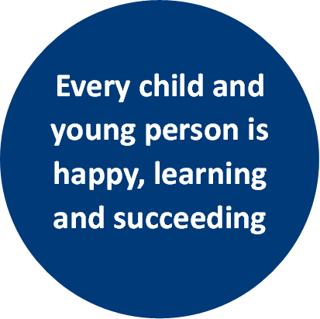
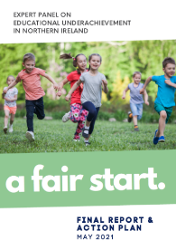
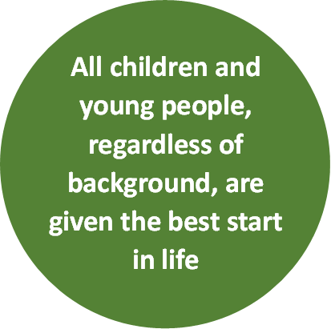
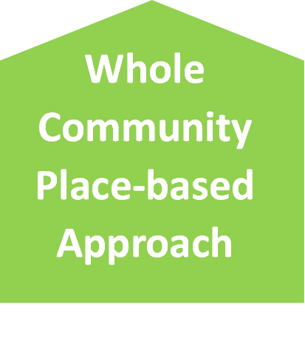
RAISE
(Raise achievement to reduce educational disadvantage)

- A Fair Start’ was published in 2021 by an Expert Panel examining the link between educational underachievement and socio-economic background. Its goals included drawing up an Action Plan for change to “ensure all children and young people, regardless of background are given the best start in life”. The Panel advocated that addressing educational underachievement “means placing equality of opportunity at the core of everything we do”.

- A substantial investment by Shared Island of c£20m over 2 years (with the possibility of 2 further years funding) will include support to codesign strategic plans in each locality, with delivery being rolled out via community-informed projects as well as cross-cutting initiatives which can span, connect and share learning across localities, regionally and on an all-island basis. This requires partnerships and on-the-ground working relationships with organisations and communities across these localities. This requires engagement and the establishment of partnerships with children/youth organisations, families, communities and schools across localities through having a visible presence.

- This approach matters because a child spends only around 14% of their lives until adulthood in a classroom and compulsory education. Schools nevertheless play a pivotal role in the lives of our children and young people, but they require support to meet the holistic needs of their pupils, all of which impact on their learning but some of which are outside the scope of a school’s remit.

- A whole community approach to education extends beyond the school gate and means children and young people are supported in all contexts in which their lives are lived. It recognises a learning and support continuum for children and families/carers, from pre-birth through to young adulthood, and multiple pathways that can be available.
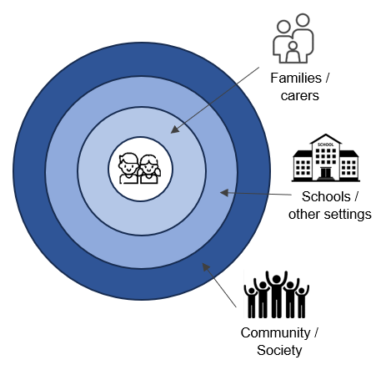
Children and young people are at the centre of a place-based and whole community approach to education.

This means local partnerships of schools, communities and families/carers helping children and young people to be happy, learning and succeeding.

This will promote inclusion and equality of opportunity, enabling more to fully develop their potential, increase their attainment and improve life chances.

- The Programme design applies a child centred, community informed and inclusion focused lens to the design and delivery of educational initiatives which are area based and in localities identified based on need.

- This involves a bespoke local Strategic Plan for each place, codesigned by schools, children, families and community and others with a role to play in supporting children’s learning in the communities in these localities.

- Collaboration enabled by these plans will build on good practice, test innovative approaches and identify and enhance pathways which promote equality of opportunity for those who face barriers to their learning and are at risk of exclusion, marginalisation and under-achievement.

- The programme will run initially for 2 years (starting in 2024) and potentially extend for a further 2 years subject to evaluation. Learning from the RAISE programme will inform policy development and better ways of working together to realise the vision of every child is happy, learning and succeeding. An Advisory / Expert Panel comprising experts and practitioners will be established to support this goal.

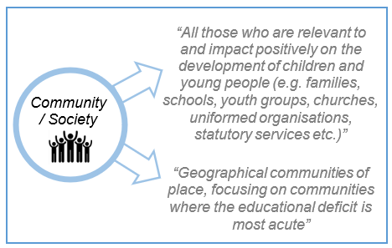
“There should be a focus on communities and families in the most disadvantaged areas. Place-based partnerships should be developed as part of a proposed new ‘Reducing Educational Disadvantage’ (RED) programme”

- The Department of Education as the responsible Department is seeking to establish a Delivery Team with a range of different skills and expertise. This is an exciting opportunity to be involved from the inception of a transformational programme in education to help shape, design and implement which will impact on the lives of children and young people. This team requires a mix of experience including programme management, locality engagement & relationship building, communications research & evaluation and administrative roles.

- A key part of the RAISE Delivery Team will be the Community Engagement Officers (8) Deputy Principal (DP) Each post will be responsible for the engagement & delivery of the RAISE programme in key localities across NI.

Main objectives of the opportunity

The Community Engagement Officers will report to the RAISE Communications and Engagement Manager.

It is envisaged that Community Engagement Officers will spend the majority of their time working in at least two of the fifteen RAISE localities or across a number of them, depending on the particular experience that they have and the local need.

The main responsibilities of each RAISE Local Co-ordinator will be:
- Local advocacy of the RAISE Programme and relationship building with a range of locality stakeholders.
- Making a distinctive impact and creating early momentum at a Locality Level including innovative community consultation, co-design and data collection that helps support the development of a bespoke localised Strategic Plan and effective rollout beyond via locally based interventions.
- Partnership building with a range of organisations and individuals including Schools, Community/Voluntary/Faith Sector, Families, Children/Young People, Political representatives, Public Sector Agencies & Private Sector.
- Establishing, managing, and chairing local reference groups.
- Oversee the Implementation of the Locality Programme Plan to ensure that it is delivered within agreed boundaries, timescales and budget.
- Oversight of the day-to-day Locality budget management to ensure that spend targets are met.
- Preparation of reports and dashboards for the governance structure that measures and reports on the success of the Programme in the Locality in liaison with the Programme Evaluation Lead in relation to benefits and outcomes against its aims and objectives.
- Support the identification, design and delivery of projects within the Locality.
- Co-ordinate the projects within the Locality and their inter-dependencies.
- Identifying opportunities for unblocking problems that have arisen around partnership working to enable the exhilaration of projects and opportunities.
- Escalation of risks and issues to the Programme Manager and governance structures as necessary.
- Co-ordinate with the community Engagement/Communications Manager the Communication and Public Relations/Affairs activities in line with the Communication & community Engagement Strategy.
- Take on any other additional responsibilities required by the Programme Manager / DE.

3. Skills requirements

What qualities, skills and experience are required from the individual

Essential Skills & Experience
- Experience of leading locality/community-based investment projects that have had positive outcomes.
- A track record of working with a range of stakeholders and representatives and using personal credibility to build relationships and add value.
- Effective facilitation and community engagement skills.
- Experience of leading the delivery of co-design and consultation processes.
- Careful planning and successful project management including budgeting and reporting.
- Strong interpersonal communication skills (written and verbal).
- Experience of writing reports and the sourcing, analysis and presentation of data and management information.
- Contribute to successful team working.
- Proficiency in MS Office suite.

Desirable Skills & Experience
- Catalysing and leading locality/community-based investment projects that have made a difference with a particular emphasis on education.

4. Personnel: Please state below

Who will the individual report to?
New Role – Communications and Engagement Manager

Who will be the individual’s line manager and/or reporting officer?
New Role – Communications and Engagement Manager

5. Transfer of learning
Please give details of how the Opportunity will benefit your organisation, the individual and their organisation.

Benefits for DE
The Department of Education is embarking on a transformative and innovative new programme of work. The RAISE programme is a whole community and place-based approach in eighteen areas across Northern Ireland to support the Department’s vision that “every child is happy, learning and succeeding”. It helps to deliver on the mission, set by the report ‘A Fair Start’, to ensure all children and young people regardless of background are given the best start in life

Benefits for other departments
Increasingly, there is a need within the public sector to collaborate with colleagues in other departments, local government and external agencies, in order to maximise the resources available, deliver collective impact and to ensure that the requirements asked of the school / V&C sector are clear and consistent. Lessons learnt as part of this process will be helpful in informing what happens in other departments and to inform future policy and delivery

Benefits for the applicant
This post offers the applicant the opportunity to develop the full range of competencies at this level i.e. Setting Direction, Engaging People and Delivering Results. It offers a unique opportunity to work in a new and transformational programme with localities on the ground to effect change and see the impact of the programmes and policies and investment and influence departmental policy as a result.

6. Logistics
Please provide details of the likely start date, duration, location, form of transport required, resources (i.e.; desk, PC, etc.) and funding arrangements for the opportunity.

Start Date: July / August 2024

Duration: 2 years with the possibility of a further extension subject to the agreement of all parties.

Location: DE is based in Rathgael House however these posts are hybrid and the majority of time will be spent in the localities where the programme will be operating. The localities will be as follows (although the grouping of area may be subject to change):
  - South Belfast, East Belfast and Ards Peninsula.
  - West Belfast and Lisburn.
  - North Belfast.
  - Derry / Londonderry.
  - Dungannon, Enniskillen, Portadown.
  - Lurgan / Craigavon, Newry.
  - Limavady, Coleraine, Ballymena.
  - Antrim, Carrick, Newtownabbey.

Access to one’s own transport is essential.

Each Community Engagement Officer will be responsible for programmes in approximately 2/3 localities.

Resources: People and Funding

Funding: DE will meet the salary costs and associated allowances for the roles and the salary will be within the NICS Deputy Principal scale of £42,315 - £45,315.

Further information: please contact Dale Heaney by email at: dale.heaney@education-ni.gov.uk or by Tel on: 028 9127 9402.

Closing Date: *Applications must be submitted by 5.00pm on Friday 28 June 2024 to:

interchangesecretariat@finance-ni.gov.uk

*These opportunities are not open to NICS staff

7. Endorsement

Interchange Manager

Signed:
Dale Heaney

Date:
14 June 2024

