Hosting Proforma
Northern Ireland Fire and Rescue Service

Name of Host
Organisation

1. Interchange Manager’s details
Shirley McDonnell
Name

Organisation/
Northern Ireland Fire and Rescue Service
Department
NIFRS Learning & Development College
120 Dungannon Road
COOKSTOWN
BT80 9BD
Address

Telephone Fax number
028 92 664221

Number
Shirley.McDonnell@nifrs.org

E-mail

Type of Opportunity
Secondment – One Year with possible extension

2. Details of hosting opportunity

Description of opportunity

Training Site Manager

The Northern Ireland Fire & Rescue Service (NIFRS) protects and serves the entire population of Northern Ireland, an area of over 5,500 square miles and with a population of 1.9 million, providing them with a range of fire and rescue services.

The post holder will be responsible for managing the efficient and effective day-to-day running of Northern Ireland Fire & Rescue Service (NIFRS) Learning & Development College (LDC) site to ensure effective training programs are delivered in a safe and well-maintained environment.

The post holder will also lead and oversee the training support team ensuring the necessary support is provided and all necessary resources are available to facilitate effective training sessions.

Main objectives of the opportunity

Key elements of the role will include:

- Facility and Equipment Management
- Team Leadership and Coordination
- Health and Safety Compliance
- Energy Management
- Security
- Contract and Financial Management.

Full Job Description and Person Specification attached in Annex 1

3. Skills requirements

What qualities, skills and experience is required from the individual

Applicants must:
Either:
- Possess a relevant degree or equivalent qualification (such as Facilities Management, Estate Management, Contracts Management, Business Management) PLUS
- A minimum of three years' experience working within a management capacity in a Facilities Management, Estate Management or Contracts Management environment.
OR
- Possess a HNC or equivalent relevant qualification (such as Facilities Management, Estate Management, Contracts Management, Business Management) PLUS
- A minimum of five years' experience working within a management capacity in a Facilities Management, Estate Management or Contracts Management environment.
OR
- A minimum of six years' experience working within a management capacity in a Facilities Management, Estate Management or Contracts Management environment.
Demonstrate:
- A minimum of two years' experience of developing and managing a team
- A sound knowledge of all forms of building construction/maintenance processes and statutory compliance testing methods
- Possess NEBOSH Health and Safety certificate or be willing to undertake training to achieve this qualification within a specified period following appointment.
- Possess an accredited Water Treatment Operator Certificate or be willing to undertake training to achieve this qualification within a specified period following appointment.
- Possess a full, current UK driving licence or have access to a form of transport which enables them to fulfil the full requirements of the job.

4. Personnel: Please state below

Who will the individual report to?
NIFRS LDC Cookstown Group Commander

Who will be the individual’s line manager and/or reporting officer?
NIFRS LDC Cookstown Group Commander

5. Transfer of learning
Please give details of how the Opportunity will benefit your organisation, the
individual and their organisation.

This is a fantastic opportunity for a suitably qualified individual to further their experience of site management within NIFRS.

6. Logistics
Please provide details of the likely start date, duration, location, form of transport required, resources (i.e.; desk, PC, etc.) and funding arrangements for the opportunity.

Start Date: As soon as a suitable candidate has been identified and a release date has been agreed.

Duration: Secondment for One Year with possible extension

Location: NIFRS Learning & Development College, 120 Dungannon Road, COOKSTOWN, BT80 9BD

Resources: This post is office based and all resources will be provided.

Funding: NIFRS will meet the salary and associated costs for the role. The salary range is currently £46,464 - £49,498.

Further information: Process will consist of shortlisting and may be followed by interview if required. For further information please contact Shirley McDonnell on Tel: 028 9266 4221 or by email at: Shirley.McDonnell@nifrs.org

Closing Date: Applications must be submitted by NOON on Friday, 14 June 2024 to:

For NI Civil Service departmental staff only: secondments@hrconnect.nigov.net

For staff from all other Partner organisations: interchangesecretariat@finance-ni.gov.uk

7. Endorsement

Interchange Manager

Signed:
Shirley McDonnell

Date:
24 May 2024

Annex 1 Job Description
Reference Number: Interchange Date: May 2024
Directorate: Service Support / Service Delivery
Department: Learning and Development
Job Title: Training Site Manager
Grade: PO5
Reports to: NIFRS LDC Cookstown Group Commander
MAIN PURPOSE
To manage the efficient and effective day-to-day running of Northern Ireland Fire & Rescue Service (NIFRS) Learning & Development College (LDC) site to ensure effective training programs are delivered in a safe and well-maintained environment.
To lead and oversee the training support team ensuring the necessary support is provided and all necessary resources are available to facilitate effective training sessions.
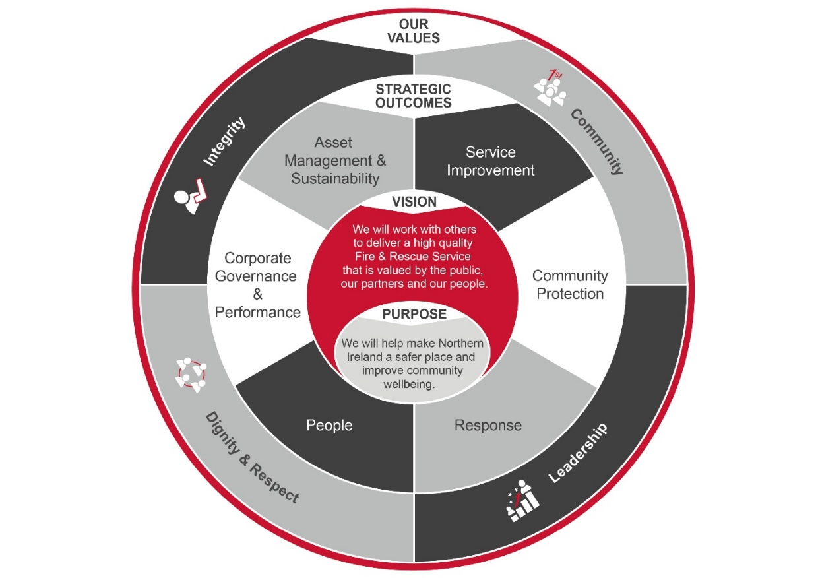
To contribute as an integral member of the Learning and Development Support team to support NIFRS in achieving it purpose, outcomes and values as outlined below:

Summary of Responsibilities:
Facility and Equipment Management

- Responsible for the management and maintenance of LDC Cookstown training facilities, buildings grounds and bespoke firefighting training props e.g. Flood Water Rescue Facility, gas props etc.

- Develop and schedule plans to ensure appropriate resources are available to support the delivery of training programs.

- Manage supplier contracts, monitor service levels and ensure timely repairs or replacements.

- Manage a programme of regular health and safety inspections to ensure statutory compliance and identify maintenance needs, address potential hazards, and implement corrective actions promptly.

- Liaise with suppliers and contractors to ensure work areas are appropriately controlled and managed.

- Manage consumable inventories to ensure that optimum levels are monitored and maintained to ensure service delivery.

- Represent LDC Cookstown and liaise with third party users of the site to facilitate training events by ensuring safe and effective use of the facilities.

- Oversee logistics relating to vehicle and operational training equipment transfer to Service Support Centre in order to ensure maximum availability of appliances and equipment for training purposes.

Team Leadership and Coordination:

- Manage the training support team, fostering a collaborative and high-performing work environment.

- Provide advice and guidance to the training support team, to ensure efficient co-ordination, scheduling and allocation of team resources to support training delivery.

Health and Safety Compliance

- Develop and implement safety protocols, including risk assessments, method statements and safe operating procedures, emergency response plans and evacuation procedures to ensure a secure training environment.

- Stay up-to-date with industry regulations, fire safety codes, and relevant legislation to ensure compliance throughout the site.

- Maintain the necessary permits, licenses, and certifications to ensure compliance with relevant external agencies and regulatory bodies.

- Responsible for statutory maintenance of Gas Fire Fighting Props and Flood Water Rescue Facility.

Energy Management
- Manage and monitor the environmental conditions within the premises, in accordance with the energy management plan to identify energy usage patterns or trends and opportunities for energy savings.

- Integrate energy management practices into maintenance and operations procedures.

Security
- Responsible for ensuring appropriate security procedures, as defined in the site security policy and plan, are in place to make the site, premises, contents and staff secure.

- Manage the out-of-hours security contract.

- Responsible for management of the key control process and management of key control during out-of-hours training or work activity

- Manage the security pass system and CCTV system in the building, including the issuing/replacement of passes and ensuring the security systems remain in working order.

Contract and Financial Management
- Contribute to overall site–wide budget proposals whilst managing a scheme of delegated authority; make informed decisions to optimise resource allocation and achieve cost-effective operations without compromising training quality.

- Manage contracts for training facilities services and equipment. This includes but is not exclusive to; managing and monitoring contractor performance, adherence to KPIs and contract specification, financial performance and contract budgets.

- Prepare appropriate business cases, tenders and quotations, in line with financial and procurement regulations, policies and procedures and corporate timescales.

- Maintain accurate records of contracts and invoices, and oversee maintenance logs and training schedules.

- Prepare reports on site operations, budget expenditure and training site performance for management review.

General Responsibilities
- Ensure continued and effective working relationships with key internal and external stakeholders such other Fire & Rescue Services, emergency services, training agencies, and external organisations to foster collaboration and ensure training needs are met.
- Provide a high level of internal and external customer service including taking ownership of customer queries and complaints and following issues through to completion.

- Undertake the duties in such a way as to enhance and protect the reputation and public profile of NIFRS.

- Comply with, and enforce, all NIFRS frameworks, policies and procedures, including but not limited to those relating to legal requirements such as equality, health and safety and information governance.

- Direct and signpost managers and officers to the appropriate source for issues outside the remit of this post.

- Undertake project work as directed by Group Commander LDC using the principles of good project management.

- Participate as directed in the NIFRS recruitment and selection procedures, in line with NIFRS Code of Practice on Recruitment and Selection.

- Undertake any other duties which may be assigned to meet organisational need and the change agenda and which are reasonably regarded as within the nature of the duties, responsibilities and grade of the post as defined.
Note: This summary of responsibilities and personal duties is not intended to be exclusive or exhaustive. The post holder may be required to undertake various other duties as deemed necessary and commensurate with the level of responsibility of the post. NIFRS reserves the right to update the Job Description to reflect the changing needs of the Service in consultation with the post holder.

Person Specification
Applicants must provide evidence by the closing date for application that they meet the following essential criteria:
Criteria | Essential/  Desirable |  | When Assessed

Knowledge, Skills and Experience
Either:  - Possess a relevant degree or equivalent qualification (such as Facilities Management, Estate Management, Contracts Management, Business Management) PLUS  - A minimum of three years' experience working within a management capacity in a Facilities Management, Estate Management or Contracts Management environment.  OR  - Possess a HNC or equivalent relevant qualification (such as Facilities Management, Estate Management, Contracts Management, Business Management) PLUS  - A minimum of five years' experience working within a management capacity in a Facilities Management, Estate Management or Contracts Management environment.  OR  - A minimum of six years' experience working within a management capacity in a Facilities Management, Estate Management or Contracts Management environment. |  | Essential | Application Form/ Pre-employment check

Knowledge, Skills and Experience continued
- Can demonstrate minimum of two years' experience of developing and managing a team  - Can demonstrate a sound knowledge of all forms of building construction/maintenance processes and statutory compliance testing methods  - Possess NEBOSH Health and Safety certificate or be willing to undertake training to achieve this qualification within a specified period following appointment.  - Possess an accredited Water Treatment Operator Certificate or be willing to undertake training to achieve this qualification within a specified period following appointment.  - Can demonstrate:  - Excellent planning, organisation, prioritising skills and attention to detail  - The ability to work individually or as a team member;  - Excellent communication skills (both oral and written)  - Strong interpersonal skills and customer orientation  - Ability to work under pressure to multiple deadlines ;  - A working knowledge of Windows and other Microsoft applications |  | Essential  Essential  Essential  Essential  Essential | Application Form/ Interview/ Assessment  Application Form/ Interview/ Assessment  Application Form/ Interview/ Assessment  Application Form/ Interview/ Assessment  Interview/ Assessment

Other Requirements
- Possess a full, current UK driving licence or have access to a form of transport which enables them to fulfil the full requirements of the job. | Essential |  | Application Form/ Pre-employment checks

Desirable
- Can demonstrate Facility Management experience in a training or emergency response environment.  - Can demonstrate a knowledge of fire safety regulations, emergency response protocols, and training methodologies.  - Possess a Prince 2 qualification.  - Can demonstrate experience of working within local government, education or the public sector.  - Possess a LGV-C Licence or be willing to undertake training to achieve this qualification if required. | Desirable  Desirable  Desirable  Desirable  Desirable |  | Application Form  Application Form  Application Form  Application Form  Application Form

