Hosting Proforma
Northern Ireland Fire and Rescue Service

Name of Host
Organisation

1. Interchange Manager’s details
Shirley McDonnell
Name

Organisation/
Northern Ireland Fire and Rescue Service
Department
NIFRS Headquarters
1 Seymour Street
LISBURN
BT27 4SX
Address

Telephone Fax number
028 92 664221

Number
Shirley.McDonnell@nifrs.org

E-mail

Type of Opportunity
Secondment – One Year with possible extension

2. Details of hosting opportunity

Description of opportunity

Information Officer

The Northern Ireland Fire & Rescue Service (NIFRS) protects and serves the entire population of Northern Ireland, an area of over 5,500 square miles and with a population of 1.9 million, providing them with a range of fire and rescue services.

Working within the Information Unit the post holder will support the delivery of an effective and efficient day-to-day information management and information security service through the provision of timely information, support and advice in the areas of data protection, freedom of information, information management and customer charter complaints

Main objectives of the opportunity

As an integral member of the Planning, Performance and Governance (PPG) team the post holder will contribute to the provision of a modern, professional and responsive information management and information security service to support the vision and mission of NIFRS, with key elements of the role including Information Management & information Security.

Full Job Description and Person Specification is attached in Annex 1

3. Skills requirements

What qualities, skills and experience is required from the individual

Applicants must:
Either:
- Possess a degree or equivalent qualification PLUS
- Have at least 1 years’ relevant experience within a large multi-disciplinary organisation* of:
- Records and information management practice including - implementation of freedom of information; data protection; environmental information; and Public Records (NI) legislation.
- Implementing information management policy and procedure.
- Providing training in respect of information management and/or information security.
- Preparing and delivering reports to senior management.
OR
- Be working towards a degree or equivalent qualification PLUS
- Have at least 2 years’ relevant experience within a large multi-disciplinary organisation* of:
- Records and information management practice including - implementation of freedom of information; data protection; environmental information; and Public Records (NI) legislation.
- Implementing information management policy and procedure.
- Providing training in respect of information management and/or information security.
- Preparing and delivering reports to senior management.
OR
- Possess at least 5 GCSEs at Grades A* - C / 9 - 4, or equivalent, to include English and Maths PLUS
- Have at least 3 years’ relevant experience within a large multi-disciplinary organisation* of:
- Records and information management practice including - implementation of freedom of information; data protection; environmental information; and Public Records (NI) legislation.
- Implementing information management policy and procedure.
- Providing training in respect of information management and/or information security.
- Preparing and delivering reports to senior management.
Demonstrate:
- Demonstrate an understanding of public sector corporate governance and information management processes.
- Possess a full, current UK driving licence or have access to a form of transport which enables them to fulfil the full requirements of the job.

4. Personnel: Please state below

Who will the individual report to?
Information Advisor

Who will be the individual’s line manager and/or reporting officer?
Information Advisor

5. Transfer of learning
Please give details of how the Opportunity will benefit your organisation, the
individual and their organisation.

This is a fantastic opportunity for a suitably qualified individual to further their experience of Information Management and Security within NIFRS.

6. Logistics
Please provide details of the likely start date, duration, location, form of transport required, resources (i.e.; desk, PC, etc.) and funding arrangements for the opportunity.

Start Date: As soon as a suitable candidate has been identified and a release date has been agreed.

Duration: Secondment for One Year with possible extension

Location: NIFRS Headquarters, 1 Seymour Street, LISBURN, BT27 4SX

Resources: This post is office based and all resources will be provided. There may be the opportunity for Hybrid Working however the post-holder will be expected to be flexible to meet the needs of the role.

Funding: NIFRS will meet the salary and associated costs for the role. The salary range is currently £29,269 - £31,364.

Further information: Process will consist of shortlisting and may be followed by interview if required. For further information please contact Shirley McDonnell on Tel: 028 9266 4221 or by email at: Shirley.McDonnell@nifrs.org

Closing Date: Applications must be submitted by NOON on Friday, 14 June 2024 to:

For NI Civil Service departmental staff only: secondments@hrconnect.nigov.net

For staff from all other Partner organisations: interchangesecretariat@finance-ni.gov.uk

7. Endorsement

Interchange Manager

Signed:
Shirley McDonnell

Date:
24 May 2024

ANNEX 1 Job Description
Reference Number: Interchange I/C 32/24 Date: May 2024
Directorate: Corporate Governance & Improvement
Department: Governance, Information & Business Support Services
Job Title: Information Officer
Grade: Scale 6
Reports to: Information Advisor

MAIN PURPOSE
To support the delivery of an effective and efficient day-to-day information management and information security service through the provision of timely information, support and advice in the areas of data protection, freedom of information, information management and customer charter complaints.
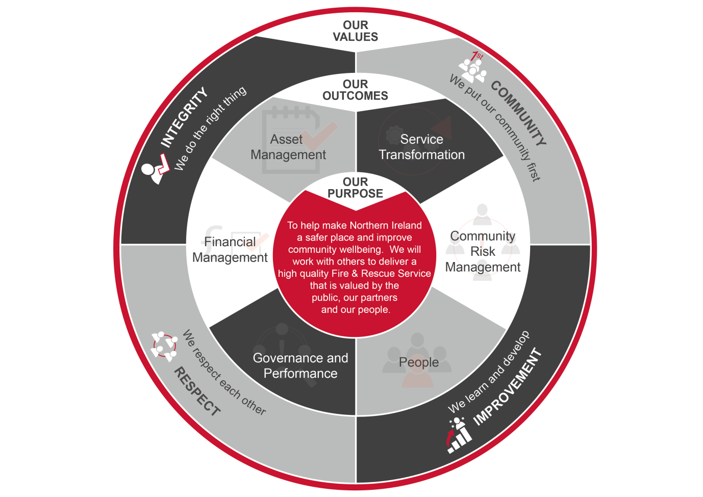
To contribute as an integral member of the Planning, Performance and Governance (PPG) team to the provision of a modern, professional and responsive information management and information security service to support the vision and mission of NIFRS as outlined below:

Summary of Responsibilities:

Information Management
- To support the delivery of an effective and efficient day-to-day information management and information security service through the provision of timely information, support and advice in the areas of data protection, freedom of information, information management and customer charter complaints.

- To assist with the organisational implementation of strategies, policies and processes covering information management and security.

- To advise and support key user groups, including the senior information risk owner (SIRO); personal data guardian (PDG); information management leads (IMLs), information asset owners (IAOs), and data protection leads (DPLs), on legislative compliance matters and internal processes and procedures.

- To provide advice in key information areas such as privacy statements; privacy impact assessments; consent; and the legal basis for using personal information.

- To maintain up-to-date Information Asset, Data Flow and Record Management Registers and ensure suitable assurance processes are established and implemented across NIFRS.

- To support the achievement of pre-defined information management performance measures.

- To support the implementation and maintenance of an effective records management system for NIFRS in accordance with relevant legislation and good practice.

- To support the achievement of compliance with the sponsor body assurance requirements with respect to information management.

- To assist the Information Advisor in investigating and reporting data breaches to the Information Commissioner, NIFRS Board, CMT and the information management group, disseminating, as necessary, related learning across NIFRS.

- To ensure timely and appropriate responses in respect of data protection, freedom of information, environmental information, assembly questions, departmental queries; official departmental correspondence; and customer charter complaints.

- To administer key databases (including those for assembly questions, departmental queries; fraud and whistleblowing) to ensure they are maintained in accordance with legislation and departmental and NIFRS policy.

- To provide accurate and timely information management updates and statistical reports to enable the NIFRS Board, SLT, the sponsoring body and other stakeholders to make appropriate and robust decisions.

- To assist the Information Advisor to provide specialist training, advice and guidance to enable the SLT and other stakeholders to discharge their responsibilities in respect of information management, fraud, whistleblowing and customer charter complaints, and as necessary contribute to the NIFRS induction process for new employees.

Information Security

- To monitor and report on the attainment of targets and milestones contained within the information security implementation plans.

- To assist the Information Advisor to maintain an information security risk register and prioritise the implementation of remedial actions based on the risk profile.

- To provide advice and guidance on key information security areas such as data sharing, privacy impact assessments, and information management storage and security requirements.

- To support the information security audit and reporting programme across NIFRS.

- To assist the Information Advisor to maintain a database of security related information e.g. legislation and guidance, accessible to all employees.

- To assist the Information Advisor to support the delivery of required compliance with the sponsor body assurance standards in respect of information security.

- To support the organisation-wide implementation of a disposal process and disposal schedule, developed in line with the sponsor body’s guidance:- Good Management, Good Records (GMGR).

- To support the Information Advisor to ensure appropriate and timely archiving of information in association with the Public Records Office Northern Ireland (PRONI)

- To support the Information Advisor in the delivery of an information security management training programme to relevant personnel and as necessary contribute to the NIFRS induction process for new employees.

- To assist the Head of PPG to implement any internal or external audit recommendations.

General responsibilities
- To prepare appropriate business cases, tenders and quotations, in line with financial and procurement regulations, policies and procedures and corporate timescales.

- To provide a high level of internal and external customer service including taking ownership of customer queries and complaints and following issues through to completion.

- To ensure continued and effective working relationships with key internal and external stakeholders such as heads of Department, Group Commanders, Area Business Managers and representative bodies.

- To represent the Information Advisor as required and provide support and cover within the PPG department to ensure resilience as far as practicable.

- To undertake the duties in such a way as to enhance and protect the reputation and public profile of NIFRS.

- To comply with all NIFRS frameworks, policies and procedures, including but not limited to those relating to legal requirements such as equality, health and safety and information governance.

- To direct and signpost managers and officers to the appropriate source for issues outside the remit of this post.

- To undertake project work as directed by the Information Advisor using the principles of good project management.

- To participate as directed in the NIFRS recruitment and selection procedures, in line with NIFRS Code of Practice on Recruitment and Selection.

- To undertake any other duties which may be assigned to meet organisational need and the change agenda and which are reasonably regarded as within the nature of the duties, responsibilities and grade of the post as defined.

Person Specification
Applicants must provide evidence by the closing date for application that they meet the following essential criteria:
Criteria | Essential/  Desirable | When Assessed

Knowledge, Skills and Experience
Qualifications & Professional Development  EITHER:  - Possess a degree or equivalent qualification  AND  - Have at least 1 years’ relevant experience within a large multi-disciplinary organisation* of:  - Records and information management practice including - implementation of freedom of information; data protection; environmental information; and Public Records (NI) legislation.  - Implementing information management policy and procedure.  - Providing training in respect of information management and/or information security.  - Preparing and delivering reports to senior management.  OR  - Be working towards a degree or equivalent qualification.  AND  - Have at least 2 years’ relevant experience within a large multi-disciplinary organisation* of:  - Records and information management practice including - implementation of freedom of information; data protection; environmental information; and Public Records (NI) legislation.  - Implementing information management policy and procedure.  - Providing training in respect of information management and/or information security.  - Preparing and delivering reports to senior management.  OR  - Possess at least 5 GCSEs at Grades A* - C / 9 - 4, or equivalent, to include English and Maths,  AND  - Have at least 3 years’ relevant experience within a large multi-disciplinary organisation* of:  - Records and information management practice including - implementation of freedom of information; data protection; environmental information; and Public Records (NI) legislation.  - Implementing information management policy and procedure.  - Providing training in respect of information management and/or information security.  - Preparing and delivering reports to senior management. | Essential | Application Form/ Pre-employment Check

Knowledge, Skills and Experience continued
- Demonstrate an understanding of public sector corporate governance and information management processes.  - Demonstrate:  - effective planning, organisation, prioritising skills and attention to detail and the ability to work individually or as a team member.  - effective communication skills (both oral and written) and the ability to provide timely and accurate information.  - a customer service orientation. | Essential  Essential | Application Form/ /Interview  Interview

Other Requirements
- Possess a full, current UK driving licence or have access to a form of transport which enables them to fulfil the full requirements of the job. | Essential | Application Form/ / Pre-employment checks

Desirable
- Experience of working in the public sector. | Desirable | Application Form/ /Interview

